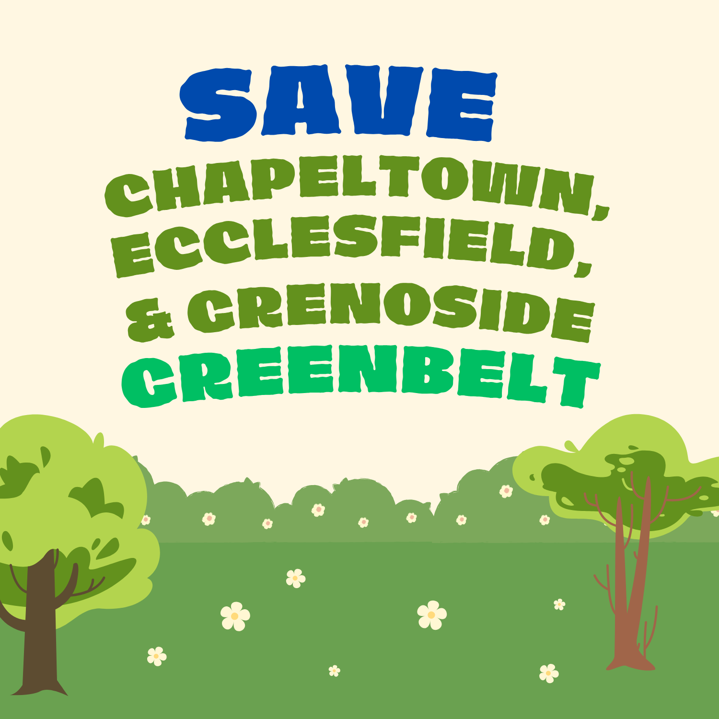
Sheffield 50/50 Cash Draw
Terms and Conditions
1. The promoter
This lottery is promoted by Save Chapeltown, Ecclesfield & Grenoside Greenbelt Community Campaign on behalf of the Sheffield Green Belt Alliance. It is a small society lottery registered with Sheffield City Council, registration number SL6653. Promoter: Save Chapeltown, Ecclesfield & Grenoside Greenbelt Community Campaign. Contact: savegandegreenbelt@gmail.com.
2. Who can enter
Entrants must be aged 16 or over. By buying a ticket, you confirm you are 16 or over. Any prize won by someone under 16 the prize will rollover to the next draw.
3. Tickets
Every ticket costs £5. Tickets are bought online and are only valid once payment has been received. Ticket numbers are allocated in order of purchase and emailed to the address given at checkout within 48 hours. That email is your ticket.
4. Closing date
Ticket sales close at 12 noon on on Saturday 19 December 2026, or earlier if total ticket sales reach £20,000, the maximum allowed for a small society lottery. If this limit is reached, we will close ticket sales immediately and announce this on our Facebook page. Any payment received after sales have closed will be refunded in full.
5. The prize
There is one cash prize of 50% of gross ticket sales, rounded down to the nearest penny. Card processing fees are paid from the campaign's share, not the prize. The final prize amount will be announced at the draw.
6. The draw
The draw will take place on Saturday 19 December 2026 and be streamed live on our Facebook page. The winning ticket will be chosen at random using an online random number generator from all valid ticket numbers.
7. The winner
We will contact the winner by email or phone within 48 hours of the draw. The prize will be paid by bank transfer, and bank details must be shared by the winner within 28 days of the draw in order to claim the prize. If the prize is not claimed within 28 days of the draw, the prize will rollover to the next draw.
8. Publicity
The winner's first name and area will be announced on our Facebook page and website. No other personal details will be published.
9. Refunds
Tickets cannot be refunded unless the draw is cancelled, or payment is received after ticket sales have closed. If the draw is cancelled, all ticket holders will receive a full refund.
10. Where the money goes
50% of gross ticket sales goes to the prize. The remaining 50%, less card processing fees, goes to the campaign to protect Sheffield's Green Belt.
11. Your data
We will use your name, email address and phone number only to run this draw and contact the winner. We will not share your details with anyone else, and we will delete them six months after the draw unless you have agreed to hear from us about the campaign.
12. Decisions
The promoter's decision on any matter relating to the draw is final.
13. Please play responsibly
For free, confidential support with gambling, visit begambleaware.org.
Questions? Email savegandegreenbelt@gmail.com

